Assignment – 2

You have been asked to:

● Create a script which can add text “This text has been added by custom script” to

/tmp.1.txt

● Run this script using Ansible on all the hosts

* Created a playbook for running script

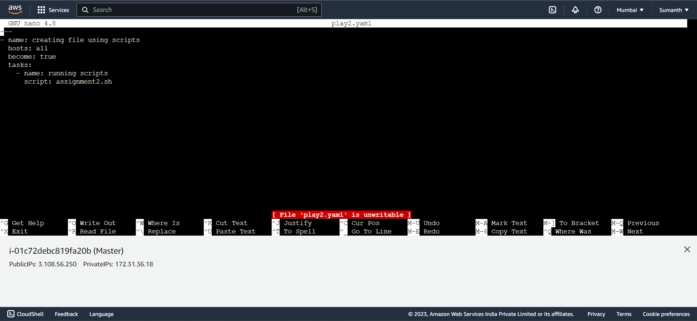

* Ran the mentioned script in all the hosts

